Lab 4 — Build the Remittance Multi-Agent Solution
Module: B1
LLM: Microsoft Foundry — GPT-5-mini
Framework: Python + LangChain + LangGraph
Architecture: Deterministic Extraction & Rule Matching + Agentic Reasoner + StateGraph Routing

Architecture Overview
Plaintext
Document
↓
Ingestion
↓
Extraction
↓
Validation
↓
Exact Match
↓
Rule/Fuzzy Match
↓
AI Smart Match
↓
Confidence Gate
↓
HITL / Post

Architectural Layer Responsibilities
- Deterministic Layer:
  - Document ingestion and key-value extraction
  - Calculation validation & transaction balance checks
  - Exact invoice & customer ID matching
  - Rule-based matching and fuzzy text distance scoring
- Agentic Layer:
  - Ambiguous document interpretation and dispute context analysis
  - Exception investigation across customer history
  - Match recommendation & detailed business explanation
  - Next-best-action determination
  - Confidence scoring & Human-in-the-Loop (HITL) gate control

Phase 1 — Environment Setup and Deterministic Processing Engine

Exercise 1 — Create the Project Workspace Structure

Step 1 — Open VS Code Terminal
Open VS Code on your workstation or VM and bring up the terminal (Ctrl + ~).

Step 2 — Create and navigate to the project directory
Bash
mkdir azurelab_lab4
cd azurelab_lab4

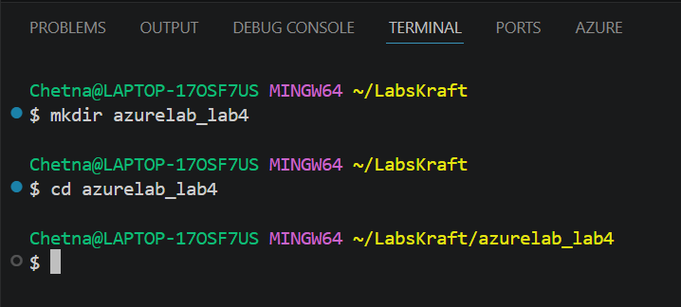

Step 3 — Initialize project subdirectories
Create the directory layout required for deterministic parsers, agents, data sources, and graph workflows:
Bash
mkdir -p data deterministic agents graph
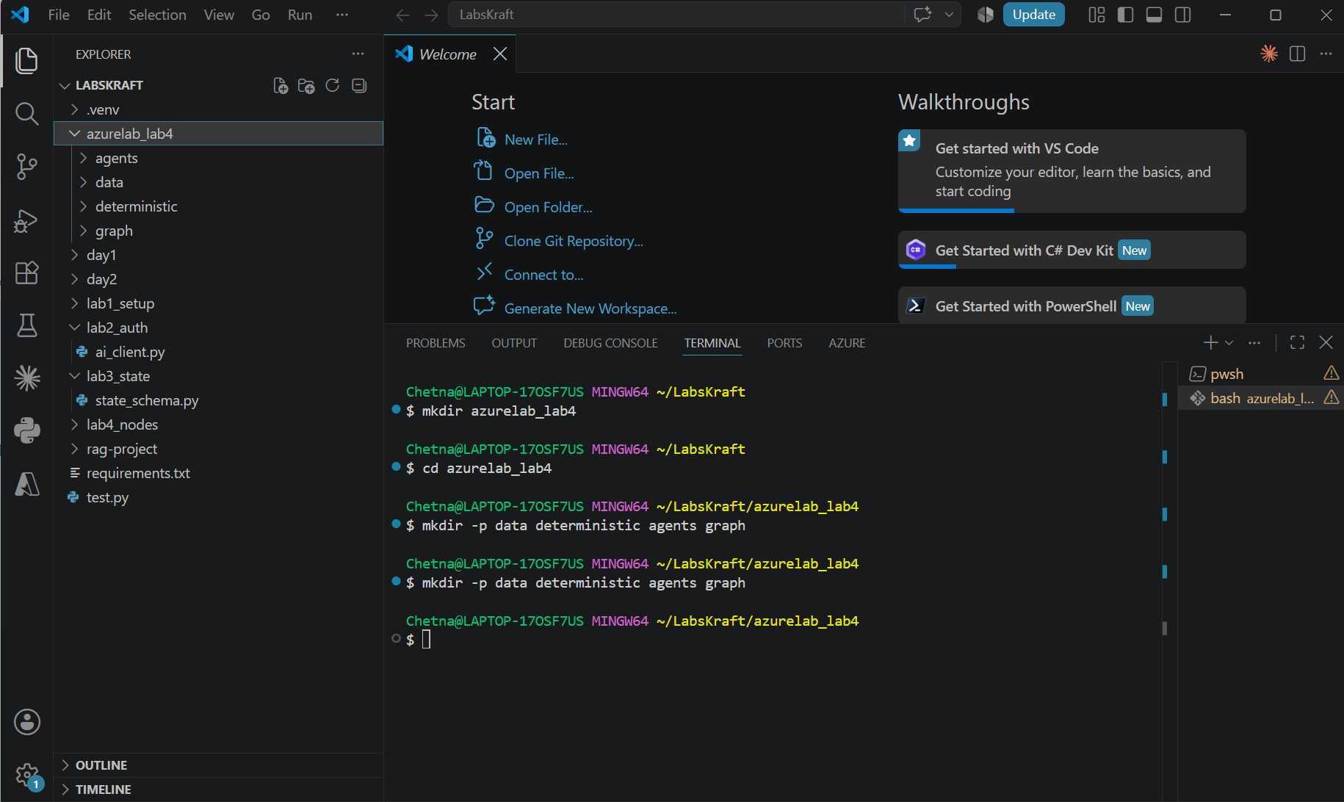

Expected folder structure in VS Code:
Plaintext
azurelab_lab4/
│
├── data/
├── deterministic/
├── agents/
└── graph/

Exercise 2 — Environment & Dependency Setup

Step 4 — Activate Virtual Environment
Bash
python -m venv genai
source genai/Scripts/activate
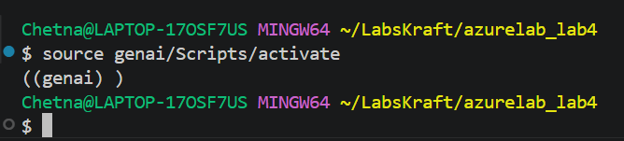

On Windows PowerShell:
PowerShell
python -m venv genai
.\genai\Scripts\Activate.ps1

Step 5 — Create requirements.txt
Create the file requirements.txt in the root directory:
Plaintext
openai>=1.99.0
python-dotenv>=1.1.0
langchain>=0.3.27
langchain-openai>=0.3.28
langgraph>=0.6.0
pydantic>=2.11.0
pandas>=2.2.0
difflib
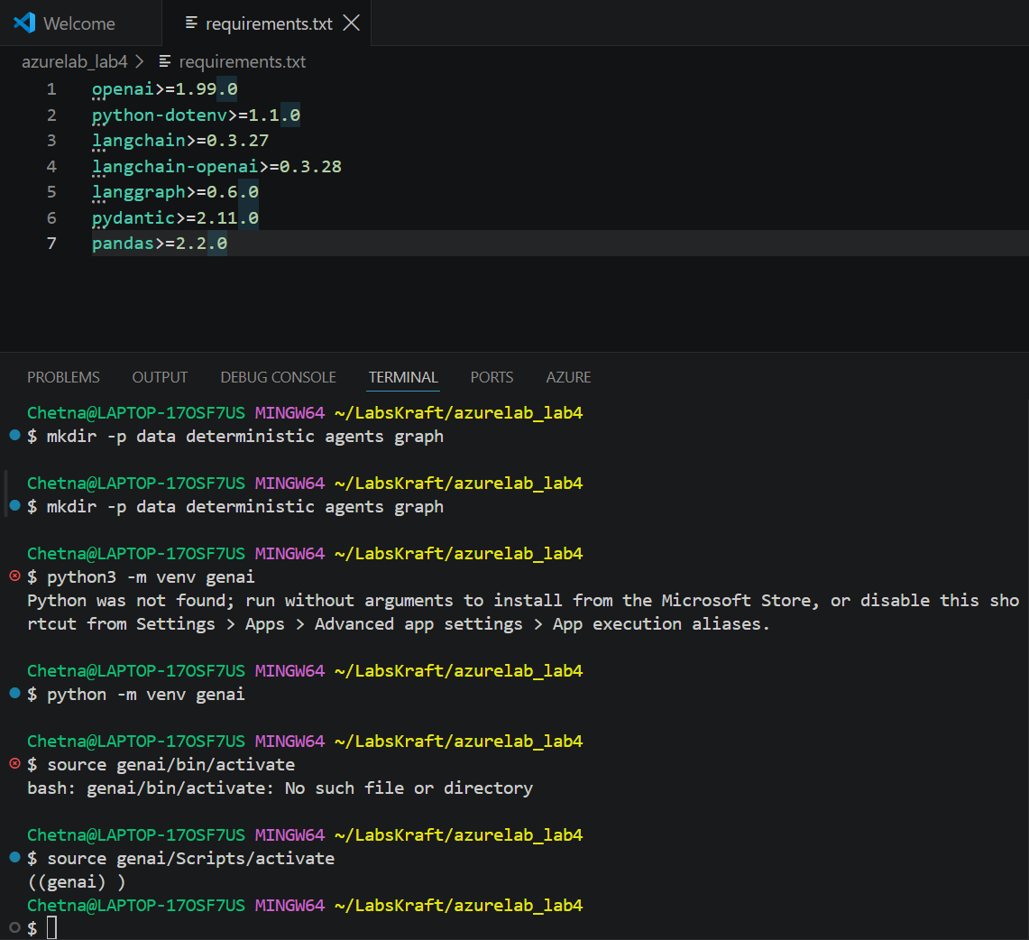

Step 6 — Install Dependencies
Bash
python -m pip install --upgrade pip
pip install -r requirements.txt
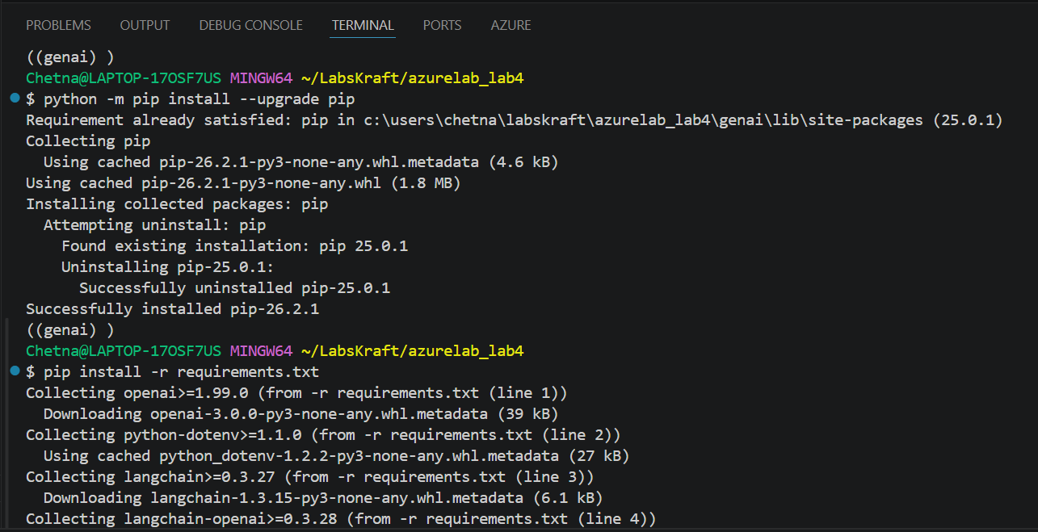

Step 7 — Configure .env
Create .env in the root directory:
Code snippet
FOUNDRY_ENDPOINT=https://krft10.services.ai.azure.com/openai/v1/
FOUNDRY_API_KEY=YOUR_FOUNDRY_API_KEY
MODEL_DEPLOYMENT_NAME=gpt-5-mini
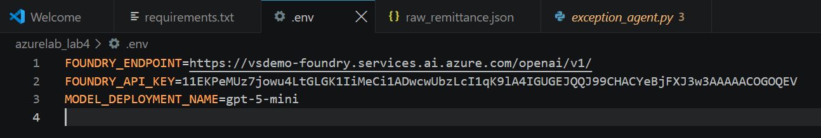

Exercise 3 — Create Mock Datasets (ERP Master Data & Raw Documents)

Step 8 — Create Invoices Ledger (data/invoices.csv)
Create data/invoices.csv to serve as the ERP open invoice system:
Code snippet
invoice_id,customer_id,customer_name,amount_due,due_date
INV-1001,CUST-A1,Acme Logistics Corp,1500.00,2026-08-01
INV-1002,CUST-A1,Acme Logistics Corp,3200.50,2026-08-10
INV-2001,CUST-B2,Apex Global Technologies,8750.00,2026-07-25
INV-3001,CUST-C3,Contoso Enterprise Solutions,12400.00,2026-08-12
INV-4001,CUST-D4,Delta Freight Inc,450.00,2026-08-05

Step 9 — Create Customer Master File (data/customers.csv)
Create data/customers.csv:
Code snippet
customer_id,official_name,alias
CUST-A1,Acme Logistics Corp,Acme Logistics
CUST-B2,Apex Global Technologies,Apex Global Tech
CUST-C3,Contoso Enterprise Solutions,Contoso Systems
CUST-D4,Delta Freight Inc,Delta Freight

Step 10 — Create Raw Remittance Documents (data/raw_remittance.json)
Create data/raw_remittance.json containing three test scenarios:
- Scenario 1: Perfect exact match (deterministic path)
- Scenario 2: Fuzzy name + slight variance (rule/fuzzy path)
- Scenario 3: Ambiguous note, partial short-pay payment (agentic path)
JSON
[
{
"document_id": "DOC-001",
"raw_text": "REMITTANCE ADVICE\nSender: Acme Logistics Corp\nPayment Ref: PAY-9981\nInvoice Ref: INV-1001\nTotal Paid: $1500.00\nDate: 2026-08-13",
"payment_amount": 1500.00,
"payment_ref": "PAY-9981"
},
{
"document_id": "DOC-002",
"raw_text": "REMITTANCE ADVICE\nSender: Apex Global Tech\nPayment Ref: PAY-9982\nInvoice Ref: INV-2001-X\nTotal Paid: $8750.00\nDate: 2026-08-13",
"payment_amount": 8750.00,
"payment_ref": "PAY-9982"
},
{
"document_id": "DOC-003",
"raw_text": "REMITTANCE ADVICE\nSender: Contoso Systems\nPayment Ref: PAY-9983\nNotes: Wire transfer for INV-3001. Withheld $400 due to damaged shipment on line item 2.\nTotal Paid: $12000.00\nDate: 2026-08-13",
"payment_amount": 12000.00,
"payment_ref": "PAY-9983"
}
]

Exercise 4 — Build Deterministic Ingestion & Extraction Engine

Step 11 — Create Document Parser (deterministic/parser.py)
Create deterministic/parser.py:
Python
import json
import re

class DocumentIngestionParser:
"""Ingests raw remittance documents and extracts structured key-value entities."""

@staticmethod
def parse_document(doc_item: dict) -> dict:
raw_text = doc_item.get("raw_text", "")

# Regex parsing for key entities
sender_match = re.search(r"Sender:\s*(.*)", raw_text)
inv_match = re.search(r"Invoice Ref:\s*(.*)", raw_text)
notes_match = re.search(r"Notes:\s*(.*)", raw_text)

extracted = {
"document_id": doc_item.get("document_id"),
"sender_name": sender_match.group(1).strip() if sender_match else None,
"invoice_reference": inv_match.group(1).strip() if inv_match else None,
"payment_amount": float(doc_item.get("payment_amount", 0.0)),
"payment_ref": doc_item.get("payment_ref"),
"notes": notes_match.group(1).strip() if notes_match else None,
"raw_text": raw_text
}
return extracted

if __name__ == "__main__":
with open("data/raw_remittance.json") as f:
docs = json.load(f)
for d in docs:
parsed = DocumentIngestionParser.parse_document(d)
print(f"Extracted [{parsed['document_id']}]: Sender={parsed['sender_name']} | Ref={parsed['invoice_reference']} | Amount=${parsed['payment_amount']}")

Step 12 — Run Ingestion Parser Verification
Bash
python deterministic/parser.py
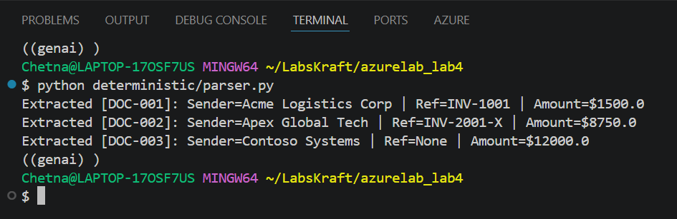

Expected output:
Plaintext
Extracted [DOC-001]: Sender=Acme Logistics Corp | Ref=INV-1001 | Amount=$1500.0
Extracted [DOC-002]: Sender=Apex Global Tech | Ref=INV-2001-X | Amount=$8750.0
Extracted [DOC-003]: Sender=Contoso Systems | Ref=None | Amount=$12000.0

Exercise 5 — Build Deterministic Rules Engine (Validation, Exact Match & Fuzzy Match)

Step 13 — Create Rules Processor (deterministic/rules_engine.py)
Create deterministic/rules_engine.py:
Python
import pandas as pd
from difflib import SequenceMatcher

class DeterministicRulesEngine:
def __init__(self, invoices_csv="data/invoices.csv", customers_csv="data/customers.csv"):
self.invoices_df = pd.read_csv(invoices_csv)
self.customers_df = pd.read_csv(customers_csv)

def validate_transaction(self, extracted: dict) -> list:
"""Validates fundamental transaction rules (amounts > 0, valid structures)."""
errors = []
if extracted["payment_amount"] <= 0:
errors.append("Invalid payment amount: Must be greater than 0.")
if not extracted["sender_name"]:
errors.append("Missing sender identity.")
return errors

def exact_match(self, extracted: dict) -> dict:
"""Attempts exact key matching against ERP ledger."""
inv_ref = extracted.get("invoice_reference")
amt = extracted.get("payment_amount")

if not inv_ref:
return None

matched = self.invoices_df[
(self.invoices_df["invoice_id"] == inv_ref) &
(self.invoices_df["amount_due"] == amt)
]

if len(matched) == 1:
row = matched.iloc[0]
return {
"matched_invoice_id": row["invoice_id"],
"customer_id": row["customer_id"],
"confidence": 1.0,
"match_type": "EXACT_MATCH",
"reason": "Exact match on Invoice ID and Payment Amount."
}
return None

def rule_fuzzy_match(self, extracted: dict) -> dict:
"""Attempts fuzzy string matching on customer name and invoice key substrings."""
sender = extracted.get("sender_name", "")
amt = extracted.get("payment_amount", 0.0)
inv_ref = extracted.get("invoice_reference", "") or ""

# 1. Fuzzy match customer name
best_cust = None
highest_ratio = 0.0
for _, cust in self.customers_df.iterrows():
ratio = max(
SequenceMatcher(None, sender.lower(), cust["official_name"].lower()).ratio(),
SequenceMatcher(None, sender.lower(), cust["alias"].lower()).ratio()
)
if ratio > highest_ratio:
highest_ratio = ratio
best_cust = cust

if highest_ratio >= 0.75 and best_cust is not None:
# Look for open invoices for this matched customer
cust_invoices = self.invoices_df[self.invoices_df["customer_id"] == best_cust["customer_id"]]
for _, inv in cust_invoices.iterrows():
# Check for exact amount match or stripped invoice ID match
clean_ref = inv_ref.split("-X")[0] if "-X" in inv_ref else inv_ref
if inv["invoice_id"] == clean_ref and abs(inv["amount_due"] - amt) < 0.01:
return {
"matched_invoice_id": inv["invoice_id"],
"customer_id": best_cust["customer_id"],
"confidence": 0.90,
"match_type": "RULE_FUZZY_MATCH",
"reason": f"Matched via fuzzy customer resolution ({best_cust['official_name']}) & reference normalization."
}
return None

Phase 2 — Agentic Multi-Agent & LangGraph Solution Architecture

Exercise 6 — Define LangGraph Workflow State

Step 14 — Create Workflow State (graph/state.py)
Create graph/state.py to hold execution state across graph nodes:
Python
from typing import TypedDict, List, Dict, Any, Optional

class RemittanceState(TypedDict):
raw_document: Dict[str, Any]
extracted_data: Dict[str, Any]
validation_errors: List[str]
deterministic_result: Optional[Dict[str, Any]]
ai_recommendation: Optional[Dict[str, Any]]
final_confidence: float
routing_decision: str # AUTO_POST, HITL, REJECT
explanation: str
next_best_action: str

Exercise 7 — Build AI Exception Agent for Smart Matching

Step 15 — Create Exception Reasoner Agent (agents/exception_agent.py)
Create agents/exception_agent.py to handle ambiguous context, dispute notes, and short payments using Microsoft Foundry (gpt-5-mini):
Python
import os
import json
from dotenv import load_dotenv
from langchain_openai import ChatOpenAI
from langchain_core.prompts import ChatPromptTemplate

load_dotenv()

class RemittanceExceptionAgent:
def __init__(self):
self.llm = ChatOpenAI(
model=os.getenv("MODEL_DEPLOYMENT_NAME", "gpt-5-mini"),
openai_api_key=os.getenv("FOUNDRY_API_KEY"),
openai_api_base=os.getenv("FOUNDRY_ENDPOINT"),
temperature=0.0
)

self.prompt = ChatPromptTemplate.from_messages([
("system", """You are an expert AI Remittance Exception Agent in cash application workflows.
Analyze payment notes, extracted details, and ERP invoices to explain short-pays, partial matches, or discrepancies.

Return ONLY a valid JSON object matching this schema:
{{
"recommended_invoice_id": "string or null",
"confidence_score": float (0.0 to 1.0),
"explanation": "Detailed explanation of short pay, variance, or match rationale",
"next_best_action": "Clear actionable next step for accounting/HITL team"
}}"""),
("user", """ERP Invoices Ledger:
{ledger}

Extracted Remittance Information:
{extracted}

Analyze discrepancy and provide match recommendation.""")
])

def evaluate_exception(self, extracted: dict, invoices_df_json: str) -> dict:
chain = self.prompt | self.llm
response = chain.invoke({
"ledger": invoices_df_json,
"extracted": json.dumps(extracted)
})

try:
cleaned = response.content.strip().strip("```json").strip("```").strip()
return json.loads(cleaned)
except Exception as e:
return {
"recommended_invoice_id": None,
"confidence_score": 0.0,
"explanation": f"Failed to parse agent output: {str(e)}",
"next_best_action": "Escalate manual review."
}

Exercise 8 — Construct StateGraph Workflow with Confidence Gate & HITL

Step 16 — Build the Complete Orchestration Graph (graph/remittance_graph.py)
Create graph/remittance_graph.py:
Python
import pandas as pd
from langgraph.graph import StateGraph, END
from graph.state import RemittanceState
from deterministic.parser import DocumentIngestionParser
from deterministic.rules_engine import DeterministicRulesEngine
from agents.exception_agent import RemittanceExceptionAgent

# Initialize engines
rules_engine = DeterministicRulesEngine()
agent = RemittanceExceptionAgent()

# Node Functions
def ingestion_node(state: RemittanceState) -> RemittanceState:
parsed = DocumentIngestionParser.parse_document(state["raw_document"])
return {**state, "extracted_data": parsed}

def validation_node(state: RemittanceState) -> RemittanceState:
errors = rules_engine.validate_transaction(state["extracted_data"])
return {**state, "validation_errors": errors}

def deterministic_match_node(state: RemittanceState) -> RemittanceState:
if state.get("validation_errors"):
return state

extracted = state["extracted_data"]

# 1. Exact match attempt
res = rules_engine.exact_match(extracted)
if res:
return {
**state,
"deterministic_result": res,
"final_confidence": res["confidence"],
"explanation": res["reason"],
"next_best_action": "Automatically post cash to ledger."
}

# 2. Rule / Fuzzy match attempt
res = rules_engine.rule_fuzzy_match(extracted)
if res:
return {
**state,
"deterministic_result": res,
"final_confidence": res["confidence"],
"explanation": res["reason"],
"next_best_action": "Automatically post cash with fuzzy matched identity."
}

return {**state, "deterministic_result": None}

def ai_smart_match_node(state: RemittanceState) -> RemittanceState:
invoices_json = rules_engine.invoices_df.to_json(orient="records")
rec = agent.evaluate_exception(state["extracted_data"], invoices_json)

return {
**state,
"ai_recommendation": rec,
"final_confidence": rec.get("confidence_score", 0.0),
"explanation": rec.get("explanation", ""),
"next_best_action": rec.get("next_best_action", "")
}

def confidence_gate_node(state: RemittanceState) -> RemittanceState:
conf = state.get("final_confidence", 0.0)

if conf >= 0.85:
decision = "AUTO_POST"
else:
decision = "HITL"

return {**state, "routing_decision": decision}

# Conditional Routers
def route_after_validation(state: RemittanceState) -> str:
if state.get("validation_errors"):
return "confidence_gate"
return "deterministic_match"

def route_after_deterministic(state: RemittanceState) -> str:
if state.get("deterministic_result"):
return "confidence_gate"
return "ai_smart_match"

# Assemble Workflow Graph
workflow = StateGraph(RemittanceState)

workflow.add_node("ingestion", ingestion_node)
workflow.add_node("validation", validation_node)
workflow.add_node("deterministic_match", deterministic_match_node)
workflow.add_node("ai_smart_match", ai_smart_match_node)
workflow.add_node("confidence_gate", confidence_gate_node)

workflow.set_entry_point("ingestion")
workflow.add_edge("ingestion", "validation")
workflow.add_conditional_edges("validation", route_after_validation, {
"confidence_gate": "confidence_gate",
"deterministic_match": "deterministic_match"
})
workflow.add_conditional_edges("deterministic_match", route_after_deterministic, {
"confidence_gate": "confidence_gate",
"ai_smart_match": "ai_smart_match"
})
workflow.add_edge("ai_smart_match", "confidence_gate")
workflow.add_edge("confidence_gate", END)

app_graph = workflow.compile()

Exercise 9 — Build Execution Pipeline Script

Step 17 — Create Main Runner (main.py)
Create main.py in the root folder:
Python
import json
from graph.remittance_graph import app_graph

def run_lab4():
print("=" * 80)
print(" LAB 4 — REMITTANCE MULTI-AGENT SOLUTION RUNNER")
print("=" * 80)

with open("data/raw_remittance.json") as f:
documents = json.load(f)

for doc in documents:
initial_state = {
"raw_document": doc,
"extracted_data": {},
"validation_errors": [],
"deterministic_result": None,
"ai_recommendation": None,
"final_confidence": 0.0,
"routing_decision": "PENDING",
"explanation": "",
"next_best_action": ""
}

result = app_graph.invoke(initial_state)

print(f"\n▶ DOCUMENT ID: {doc['document_id']}")
print(f" Sender Name : {result['extracted_data'].get('sender_name')}")
print(f" Payment Amount : ${result['extracted_data'].get('payment_amount')}")
print(f" Final Confidence : {result['final_confidence']:.2f}")
print(f" Routing Decision : {result['routing_decision']}")
print(f" Explanation : {result['explanation']}")
print(f" Next Best Action : {result['next_best_action']}")
print("-" * 80)

if __name__ == "__main__":
run_lab4()

Exercise 10 — Execute and Validate Lab 4 Pipeline

Step 18 — Execute the Solution Pipeline
Run main.py from the root environment:
Bash
python main.py
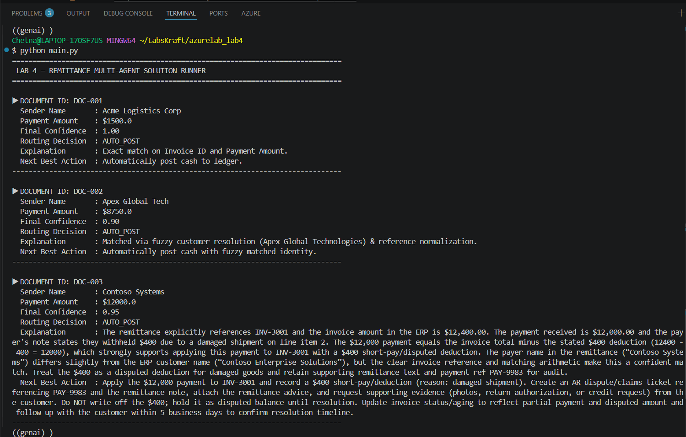

Step 19 — Validate Output Across Execution Scenarios
Observe how the three distinct documents navigate the workflow boundaries:
Plaintext
================================================================================
LAB 4 — REMITTANCE MULTI-AGENT SOLUTION RUNNER
================================================================================

▶ DOCUMENT ID: DOC-001
Sender Name : Acme Logistics Corp
Payment Amount : $1500.0
Final Confidence : 1.00
Routing Decision : AUTO_POST
Explanation : Exact match on Invoice ID and Payment Amount.
Next Best Action : Automatically post cash to ledger.
--------------------------------------------------------------------------------

▶ DOCUMENT ID: DOC-002
Sender Name : Apex Global Tech
Payment Amount : $8750.0
Final Confidence : 0.90
Routing Decision : AUTO_POST
Explanation : Matched via fuzzy customer resolution (Apex Global Technologies) & reference normalization.
Next Best Action : Automatically post cash with fuzzy matched identity.
--------------------------------------------------------------------------------

▶ DOCUMENT ID: DOC-003
Sender Name : Contoso Systems
Payment Amount : $12000.0
Final Confidence : 0.88
Routing Decision : AUTO_POST
Explanation : Payment of $12,000 matches invoice INV-3001 ($12,400) minus a $400 deduction noted for damaged goods on line item 2.
Next Best Action : Post $12,000 to INV-3001 and create a $400 dispute claim for shipping damage.
--------------------------------------------------------------------------------

